Collaboration: I worked alone on this assignment.

1. List the owner number, first name, and last name for all owners. The first name should appear in uppercase letters and the last name should appear in lowercase letters.

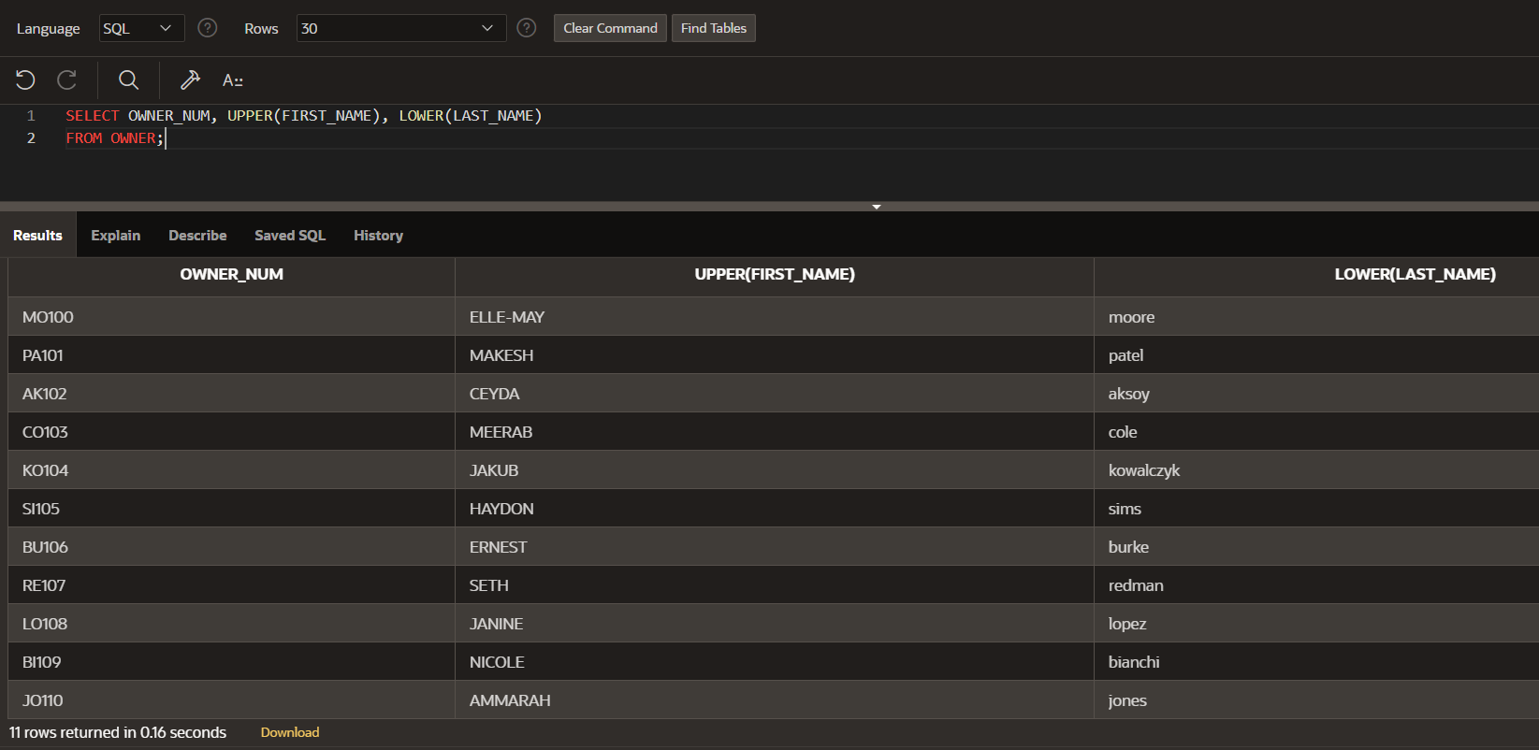

1. List the owner number and last name for all owners located in the city of Seattle. Your query should ignore case. For example, a customer with the city Seattle should be included, as should customers whose city is SEATTLE, SEAttle, SeAttle, and so on.

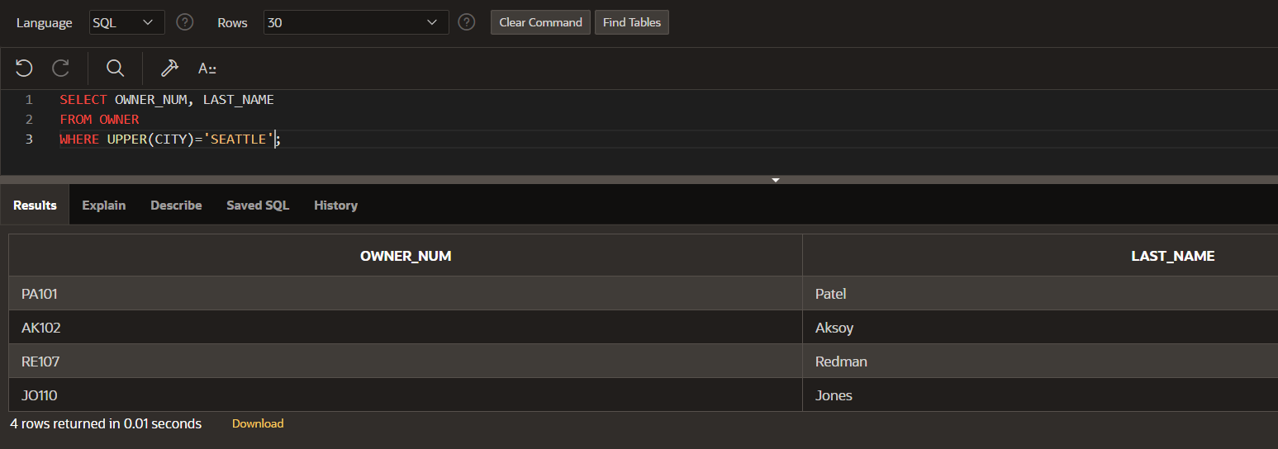

1. StayWell is offering a monthly discount for residents who pay their rent on a quarterly basis. The discount is 1.75 percent of the monthly fee. For each property, list the office number, address, owner number, owner’s last name, monthly rent, and discount. The discount should be rounded to the nearest dollar.

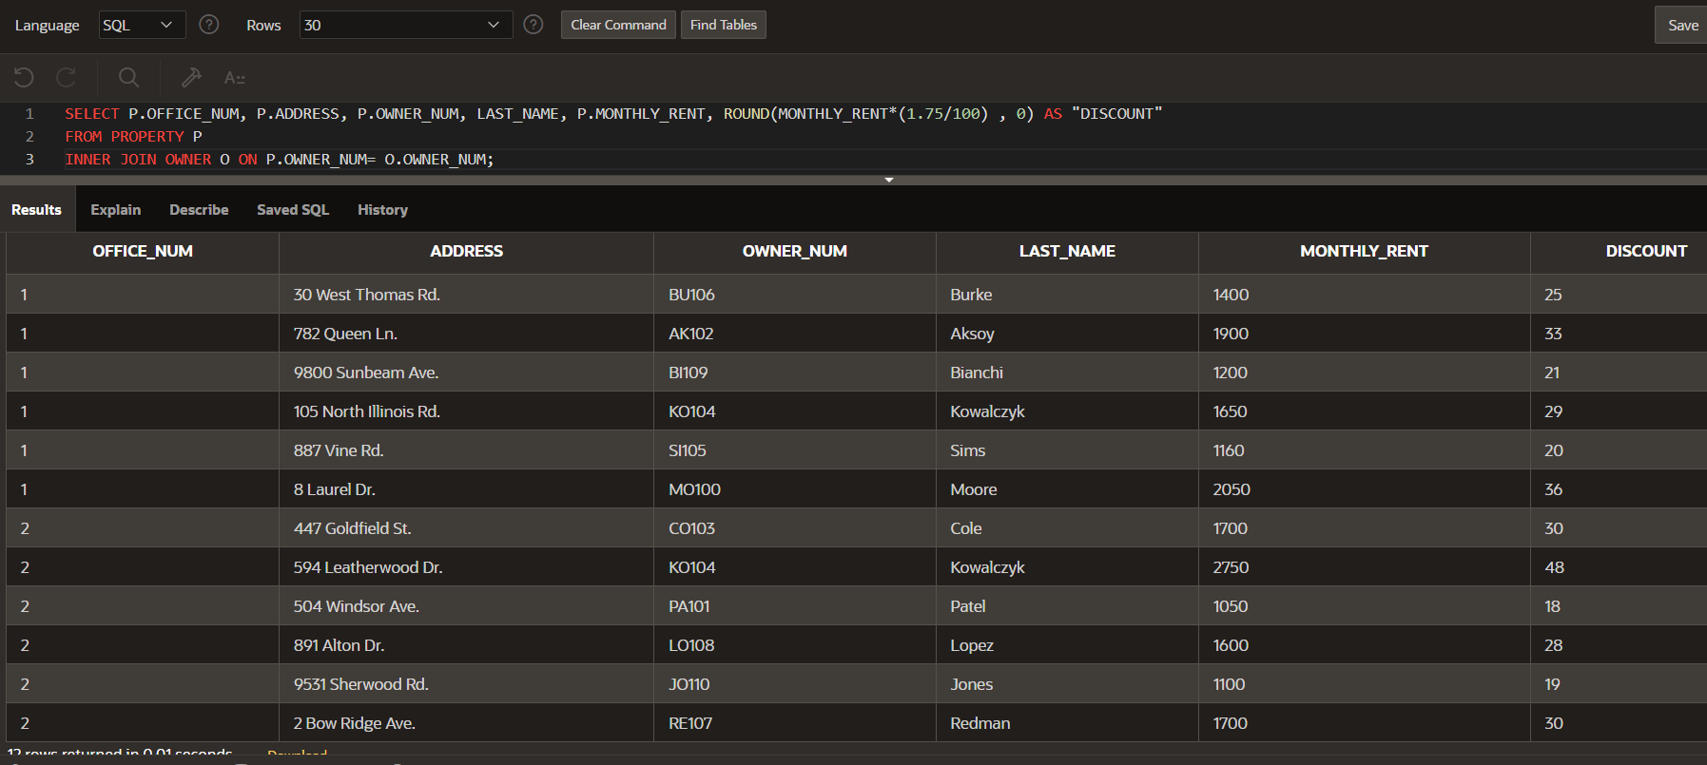

1. Write PL/SQL or T-SQL procedures to accomplish the following tasks:
2. Obtain the first name and last name of the owner whose number currently is stored in I_OWNER_NUM. Place these values in the variables I_FIRST_NAME and I_LAST_NAME. Output the contents of I_OWNER_NUM, I_FIRST_NAME, and I_LAST_NAME.

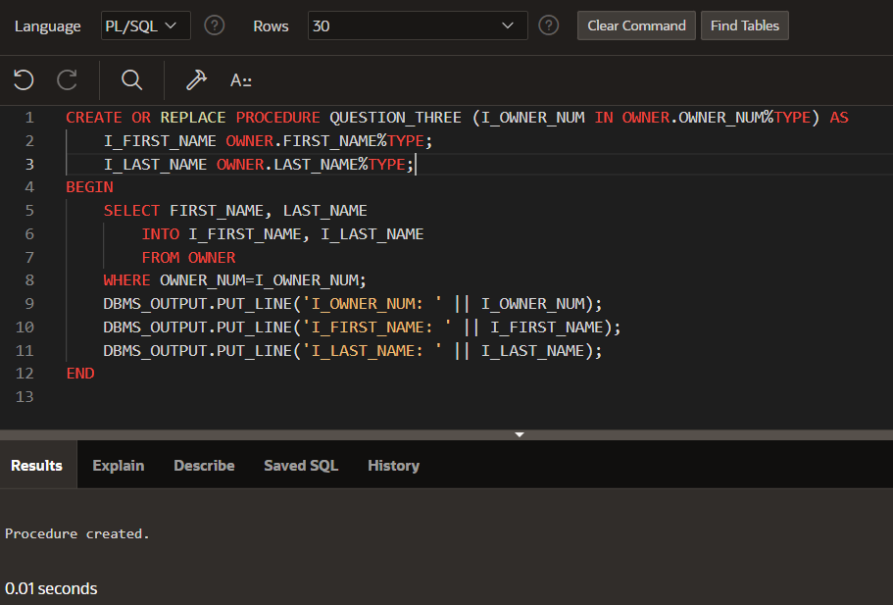

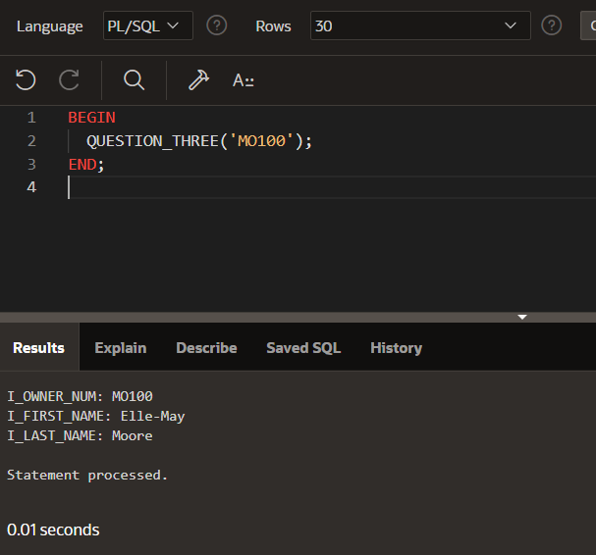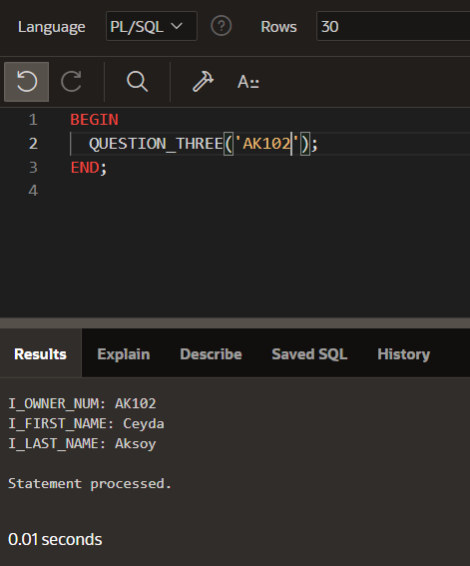

1. Obtain the office number, address, owner number, owner first name, and owner last name for the property whose property ID is currently stored in I_PROPERTY_ID. Place these values in the variables I_PROPERTY_ID, I_ADDRESS, I_OWNER_NUM, I_FIRST_NAME, and I_LAST_NAME, respectively. Output the contents of I_PROPERTY_ID, I_ADDRESS, I_OWNER_NUM, I_FIRST_NAME, and I_LAST_NAME.

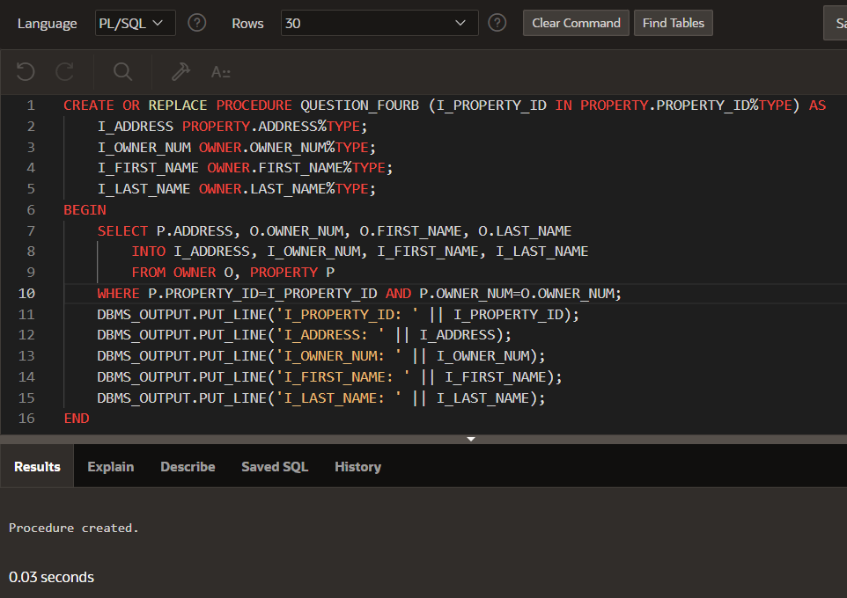

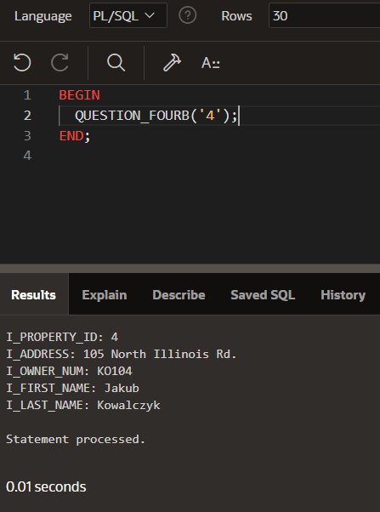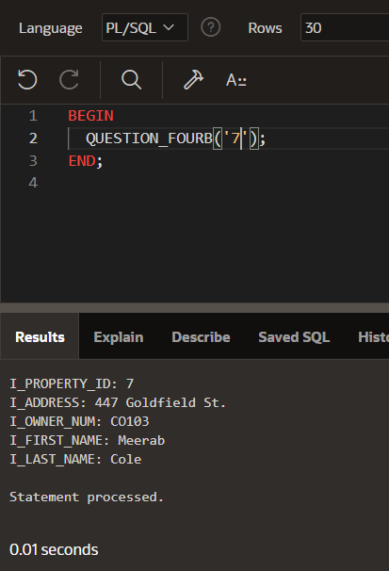

1. Add a row to the OWNER table.

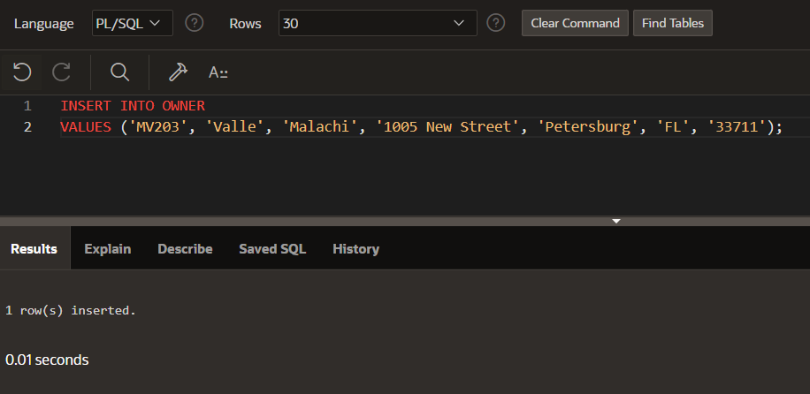

1. Change the last name of the owner whose number is stored in I_OWNER_NUM to the value currently found in I_LAST_NAME.

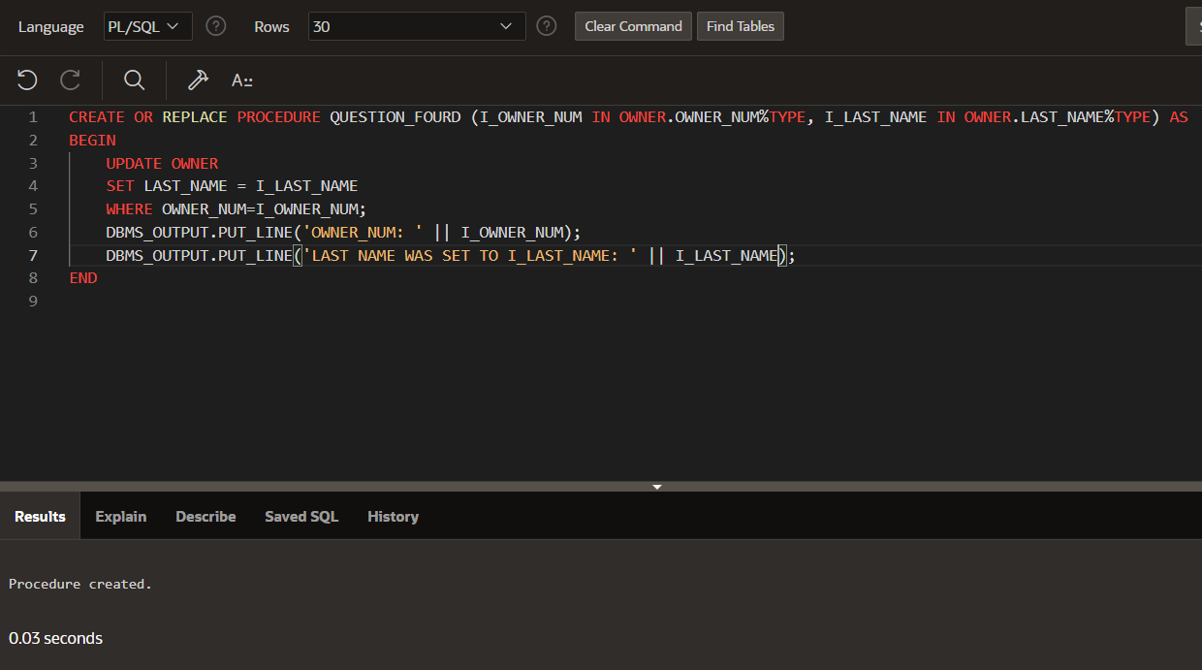

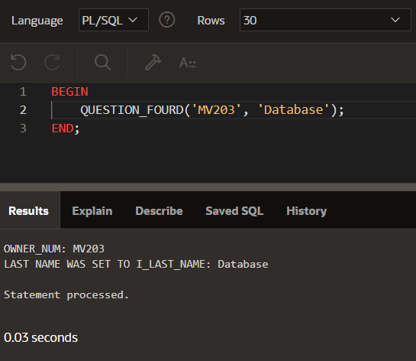

1. Delete the owner whose number is stored in I_OWNER_NUM.

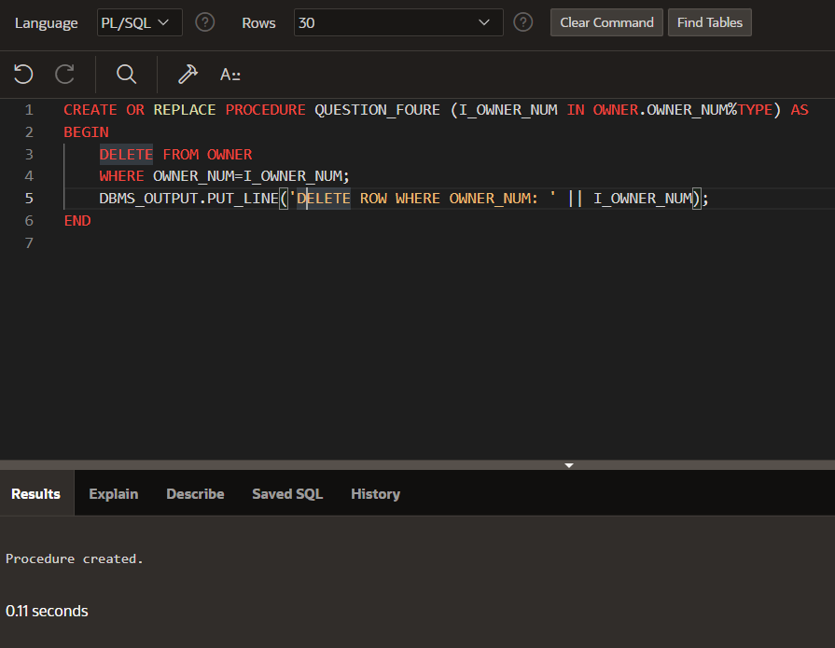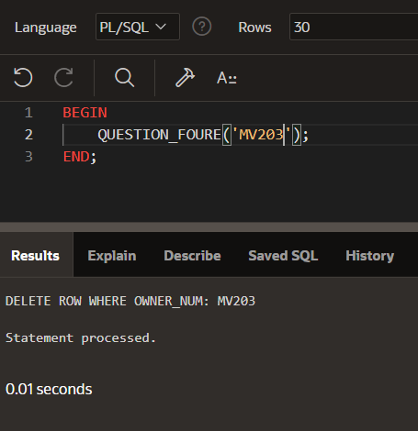

1. Write PL/SQL or T-SQL procedures to retrieve and output the office number, address, monthly rent, and owner number for every property whose square footage is equal to the square footage stored in I_SQR_FT.

